HARROW COUNCIL

SUPPLEMENTAL ADDENDUM

PLANNING COMMITTEE

30th May 2018

1/02 | HEADS OF TERMS UPDATE  (Pages 75-76  Add the following head of term:  - S106 Monitoring fees of £3,162.00 upon completion of the s106 agreement  - The Council’s legal fees associated with the drafting/reviewing/completion of the s106 agreement  CONSULTATION UPDATE  (Page 89)  Representations were received from (NB more than one response was received from some properties):  - 297 Whitchurch Lane  - 4 Moore Court  - 64 Aldridge Avenue  - 65 Aldridge Avenue  - 209 Headstone Lane  - 23 Buckingham Gardens  - 41 Merlin Crescent  - 23 St Brides Court  - 38 St Brides Avenue  - 268a Camrose Avenue  - 58 Bransgrove Road  - 52 Bridgewater Gardens  - 218 Camrose Avenue
1/03 | HEADS OF TERMS UPDATE  (Pages 137  Correct the following head of term:  The Travel Plan monitoring fee (£10,000) should be payable upon completion of the s106 agreement  The Travel Plan bond (£60,000) should be required upon the attendance reaching 4,000 on three occasions within one season  Add the following heads of term:  - S106 Monitoring fees of £4,713 upon completion of the s106 agreement  - The Council’s legal fees associated with the drafting/reviewing/completion of the s106 agreement  CONSULTATION UPDATE  (Page 150)  Representations were received from (NB more than one response was received from some properties):  - 23 Buckingham Gardens  - 218 Camrose Avenue  - 165 Turner Road  - 32 St Brides Avenue  - 297 Whitchurch Lane  - 41 Merlin Crescent  - 38 St Brides Avenue  - 52 Bridgewater Gardens  - 218 Camrose Avenue  - 318 Whitchurch Lane  - 69 Taunton Way  - 23 St Brides Avenue  - 52 Bridgewater Gardens  - 4 Moore Court  - 297 Camrose Avenue  - 209 Headstone Lane  - 62 Aldridge Avenue  - 64 Aldridge Avenue  - 8 Dale Avenue
2/01 | Addendum Item 1:  Page 199 ADD an additional condition number 6:  Joint Development  No part of the extension hereby permitted shall be constructed beyond a height of 2m above ground level until all of the foundations between No’s 53 and 55 St. Michael’s Crescent have been completed to Building Control standards, and the Local Planning Authority notified in writing that such has occurred. The development shall thereafter be carried out and retained as approved.  Reason: To ensure that there is a reasonable prospect of both developments being carried out and completed in the interests of safeguarding residential amenity.
2/02 | Addendum Item 1:  Paragraph 6.2.1: replace P/1759/17 with P/5427/17.  Addendum Item 2:  Paragraph 6.2.2: replace P/1759/17 with P/5427/17.
2/05 | Pages 293 – 339  Amend Paras 1.9, 6.2.10, 6.7.1: The site is located in PTAL 2 and not 1b  Amend Para 6.3.8 -reference to the latest site plan drawing: 17/3446/7 Rev E  Add Para 6.6 - Residential Amenity (Neighbouring properties). The applicant has undertaken a Daylight and Sunlight assessment of the rear dormer window.  Daylight:  The Building Research Establishment (BRE) target for vertical sky component (VSC) is 27%. The results below show that the dormer window achieves a VSC of 39.62% and so it will remain very well lit. In addition, there is no reduction in the VSC value as a result of the proposed building. There will therefore be no noticeable difference for the occupier.  Sunlight:  The BRE target for the annual probable sunlight hours (APSH) is 25% of which 5% should occur during the winter months. The results below show that the dormer window achieves an APSH of 84% of which 28% arises during the winter months. The room will therefore remain very well sun-lit. In addition, there is no reduction in the APSH as a result of the proposed building. There will therefore be no noticeable difference for the occupier.  The assessment report confirms the proposal is in compliance with BRE Guidance and no noticeable difference in light levels will be apparent for the occupier(s) meeting Council’s objectives regarding natural light amenity.  Add to Appendix 1 (3) Approved Drawing and Documents:  Daylight and Sunlight Assessment letter dated 24 May 2018 – Received 25/05/2018  Delete para 6.6.5
2/07 | Addendum Item 1  Replace condition no. 2 on page 402 with (to update drawing nos. with PRO/GROUND/01 REV A and PRO/BLOCK/01 REV A):  2. Approved Drawing and Documents  The development hereby permitted shall be carried out in accordance with the following approved plans and documents: Design and Access Statement; EXT/BLOCK/01; EXT/FRONTELEV/01; EXT/GROUND/01; EXT/REARELEV/01; EXT/SIDEELEV/01; PRO/GROUND/01 REV A; SITE LOCATION PLAN; PRO/BLOCK/01 REV A; PRO/FIRST/01; Sewer Map; Surface Water Management Plan; PRO/SS/01; EXT/FIRST/01; PRO/FRONTELEV/01; PRO/ LOFTFLOOR/01 REV A; PRO/REARELEV/01 REV A; PRO/ROOFPLAN/01 REV A; PRO/SECTION/01 REV A; PRO/SIDEELEV/01 REV A  Reason: For the avoidance of doubt and in the interests of proper planning.  Addendum Item 2  Replace ‘Proposed site plan’ drawing in page no. 427 with:  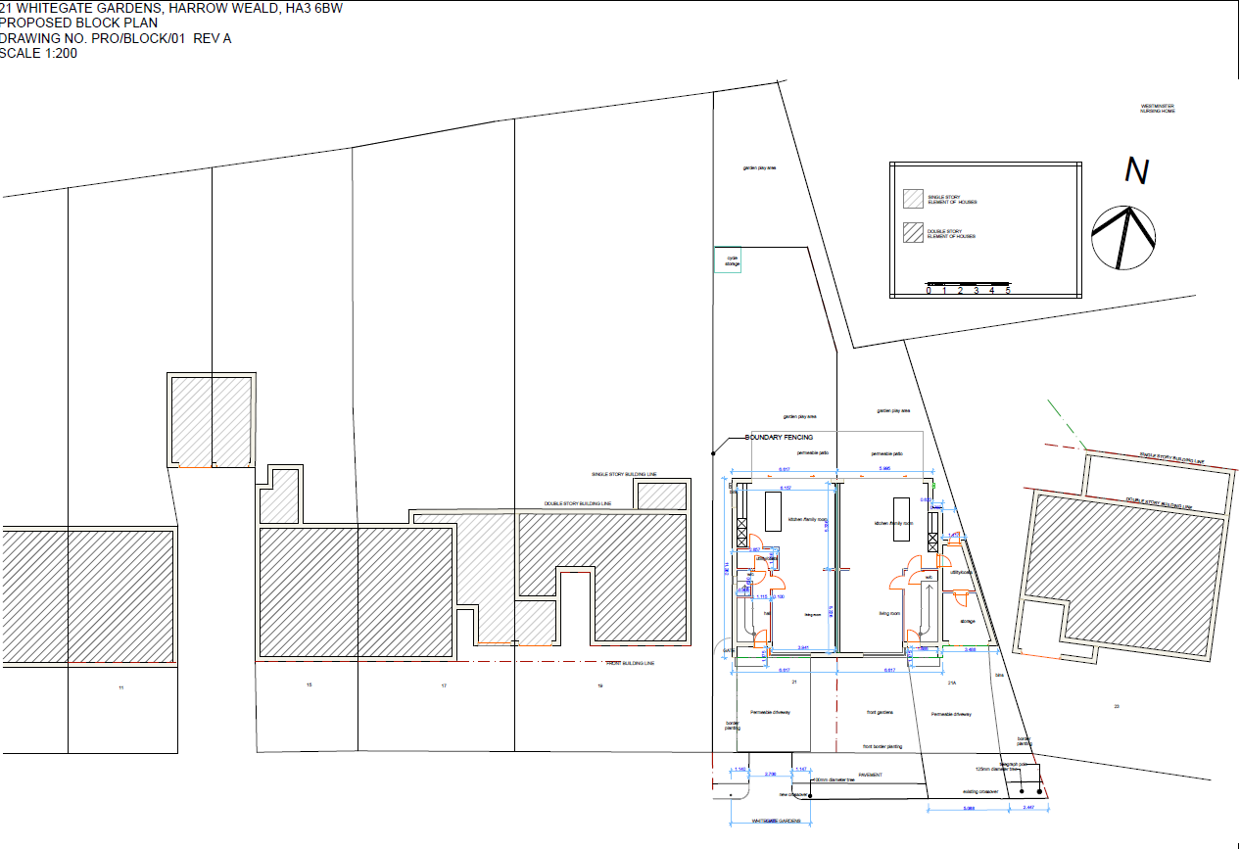  Addendum Item 3  Replace ‘Proposed ground floor plan’ drawing in page no. 428 with:  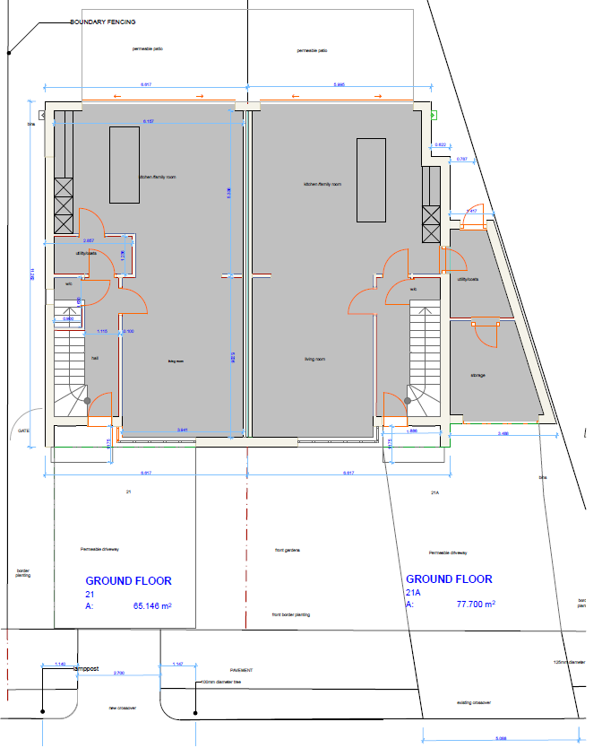
2/12 | Addendum Item 1:  Table at Paragraph 4.3:  - Number of Objections: replace 0 with 1  - Number of other Representations: replace 1 with 0  Addendum Item 2:  Table at paragraph 4.5  In Officer Comments column – replace last paragraph with:  Noted, however please note that due to the siting of the proposed conservatory extension it would not affect the existing on-site parking provision, or restrict access to the existing garage.  Addendum Item 3:  Paragraph 6.2.3:  Remove the following from the end of the first sentence - “and the proposed extension would have”.

Agenda Item 10 – Representations on Planning Applications

P/0073/18 – 74 Whittington Way | Objector #1: Mr. Jonathan Simons, Resident, on behalf of several local residents  Applicant: Matthew Roe
P/5747/17 - West House Gallery | Objector #1: Mrs Dalgleish, Resident  Applicant: Cynthia Wells
P/0966/18 – 21 Whitegate Gardens | Objector #1: Girish Patel  Applicant: TBC

